Edgar Allen Poe Writing Assignment
You will be writing your own short stories or poems that encompass similar elements and themes that are found within Edgar Allan Poe’s works that we’ve read in class so far. His use of symbols and dark imagery is something to keep in mind during this assignment. These include, but are not limited to: The Tell-Tale Heart, The Raven, The Black Cat, and Annabel Lee. Remember everything we’ve discussed on Poe’s influence during the Romanticism era and his use of the Gothic writing style. Try and follow similar structures and rhyme schemes that he uses in his work above. Refer back to the texts if you need additional help or feel free to ask me.
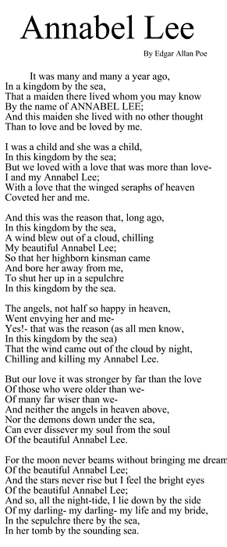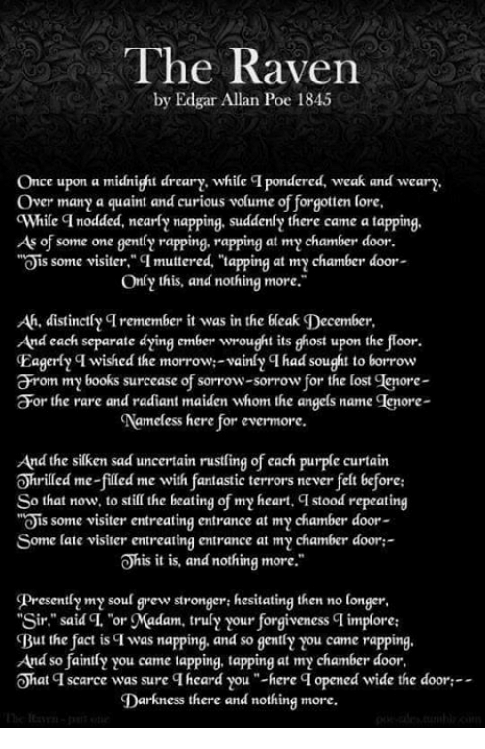
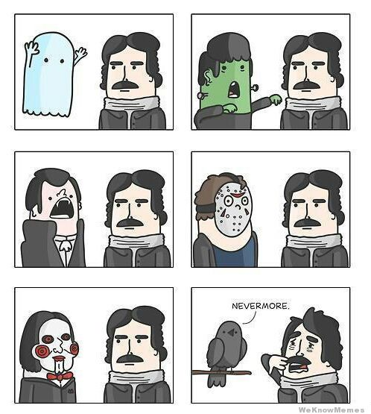

Refer to this passage if you’re still unsure of what themes to include in your writing:
Although Poe's works all tie in to each other, they all still carry their own originality. Poe presents a lot of death and tragedy throughout his poems and stories; however, they are all written from different inspirations and different events in his life. They are all very much common, yet their uniqueness also distinguishes them from repetition and is able to relate to one another without wearing out his style of message he is trying to send towards readers. The mind sets of the characters and the events that occur in each story all relate, due to their insanity, acts of murder caused by distress, and trying to find peace in unusual practices or wrong doings, or simply just death caused by sickness.
Poe's Image of Dead Beauties
An example of Poe's use of revolving stories around fallen beauties, is his story, none other than, "The Raven". During the story, the main character experiences loss, not so much in a sense of just losing a loved one, but in a way in which the character is in denial. He is not able to accept that his beloved mistress is deceased. Poe includes this writing theme in the majority of his stories, including his story "The Black Cat".
Essay Criteria:
- MLA Format (Times or Ariel, 12-point font, double spaced, page numbers, 1-inch margins, heading, title)
- 1-2 pages
- Clear use of thematic elements and key ideas found in Poe’s work
- Proofreading for grammar, diction, spelling, sentence structure
- This paper is worth 50 points

Get creative and have fun!

